Capacitors

Name: ____________________________

Download and run the simulation:
https://phet.colorado.edu/en/simulation/legacy/capacitor-lab
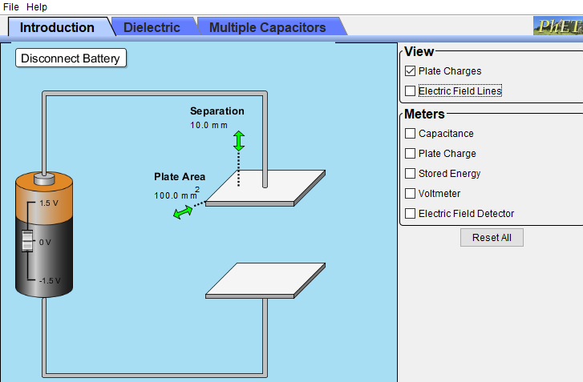
Familiarize yourself with the simulation. Play around with the settings, change the battery voltage, the distance between the plates of the capacitor and area of the capacitor plate. When you are finished testing all the settings, click on the “Reset All” button.
Step 1: Set the separation “d” between the plates to 5 mm (or 0.005 m since 1 m = 1000 mm) by dragging the green double arrow symbol above the upper plate of the capacitor. Plate area by default is 100 mm² (or 100 x 10⁻⁶ m²), do not change it.
Step 2: Under “Meters” menu check the box labeled as “Capacitance”. The capacitance of the capacitor is now displayed. Write down the values of the plate area “A”, separation “d”, and the capacitance “C” in the table on the next page (e.g. if the capacitance is 1.77 x 10⁻¹³, enter it as 1.77E-13 into the table).
Step 3: Keeping the area fixed A = 100 x 10⁻⁴ m², change the separation between the plates and record the new capacitance along with the new distance in the table below.
Step 4: Repeat step 3 for 4 other distances, record the separation and the corresponding capacitance in the table below.
Area  (m²) | Separation d  (m) | Capacitance  (F)
100 x 10⁻⁶ | 0.005 | 0.18E-12
100 x 10⁻⁶ | 0.006 | 0.15E-12
100 x 10⁻⁶ | 0.007 | 0.13E-12
100 x 10⁻⁶ | 0.008 | 0.11E-12
100 x 10⁻⁶ | 0.009 | 0.10E-12
100 x 10⁻⁶ | 0.1 | 0.09E12

Step 5: Open the Online Graph Maker at https://chart-studio.plotly.com/create/#/
Step 6: Use your mouse to select only the data in the last two columns of your table above (starting from 0.005, not including the heading row that has d and Capacitance), copy this data. Paste this data into the first two columns of the grid on your Online Graph Maker webpage clicking in the first cell of the grid in Column A and pressing ctrl+v on the keyboard.
Step 7: Click on “+Trace” button, and from the drop-down menu in front of X select “A”, from the from the drop-down menu in front of Y select B. So, it will make plat with data in column A (separation d) of the grid along the x-axis and data from column B (capacitance) along the y-axis. You will see the graph appear under the grid. Notice the trend on the graph, as the separation between the plates increase, the capacitance of the capacitor decreases.
Take a picture (or screenshot) of your graph and paste it in the space below.
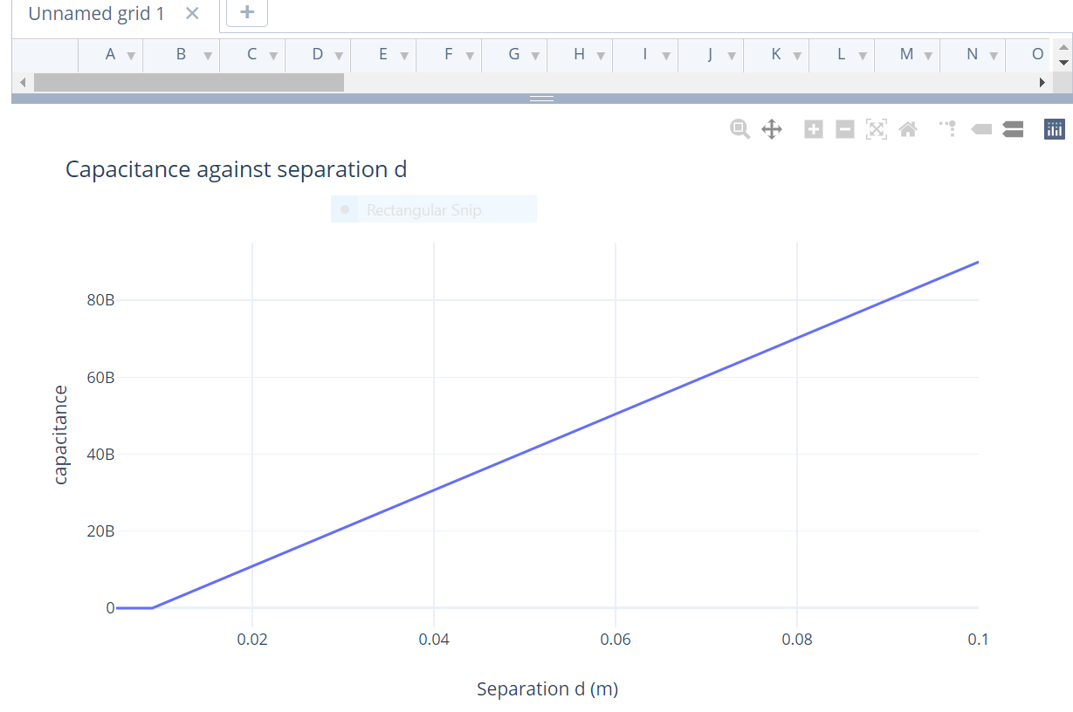

Step 8: Let’s find out how the capacitance depends on the area of the capacitor plates. Keeping the separation fixed, increase the area of the plates by dragging the green double arrow near the edge of the top plate. Notice how the capacitance changes as you increase the area, notice how it changes when you decrease the area.
Does the capacitance increase or decrease as the area of the plates in increased?
Your answer: Yes, there is an increase in capacitance when the plate area increases and a decrease when reduced.

Step 9: Let’s fit the data to a mathematical function. From the left-hand side menu, click on “Analyze” and from the drop-down menu click on “Curve Fitting”. You will see a “+fit” button appear, click on it. From the drop-down menu in front of “Select A Trace”, select trace 0. Then click on the “Advanced” button. In the “Custom Function” box, delete the “m*x+b” and type in P/x. Click anywhere outside this box. Under “Parameter Estimates” in front of P scroll up the arrow and select 1. Click on “Run” button of this menu. You will see a fit curve appear that goes through the data on your graph. Notice that the P value under the “Parameter Estimates” has changed, this new value best fits your data, copy this value of P and past it below.
P = 7741494.631194668
Write this value in scientific notation (for example if it is 4.97235e-16, you would write it as 4.97235 x 10⁻¹⁶)
P = 7.74 x 10⁶
Step 10: The capacitance of a parallel plate capacitor is given by:
$$C= \frac{Aє_{0}}{d}$$
Where $є_{0}$ is the permittivity of free space.
Since we kept the area fixed in our experiment, we fit our data to the function:
$$C= \frac{P}{x}$$
Our x is the same as d, the separation between the plates. That means:
$$P= Aє_{0}$$
You already know the value of P from your fit to the data, and Area A = 100 x 10⁻⁶ m². Use these values in the above equation to find $є_{0}.$ Show all your work below.
7.74 x 10⁶ = $100 x 10-16×ϵ0$
$є_{0}$ = (7.74 x 10⁶) / (100 x 10⁻⁶ m²⁾
= 7.74 x10¹⁰

$є_{0}(experiment)=$ 7.74 x 10¹⁰
Actual value of the permittivity of free space $є_{0}$ is:
$$є_{0}\left(actual\right)=8.85 x {10}^{-12}$$
Step 11: Find the % error. Show all your work below:
$$\% error= \left|\frac{є_{0}\left(8.85 x {10}^{-12}\right)-є_{0}(7.74 x {10}^{10} }{є_{0}(8.85 x {10}^{-12})}\right| x 100$$

$\% error=$ __-8.75 x10²³___________
Step 12: So far, we have only looked at the capacitance of a capacitor, it depends on the geometrical shape of the capacitor (area and separation of capacitor plates). It is independent of the battery voltage that is used to charge the capacitor.
Let’s charge the capacitor now. Adjust the separation to 10 mm. Adjust the battery voltage to 1.5 V using the sliding bar on the battery. Under the “meters” menu check the boxes “Capacitance”, “Plate Charge”, “Stored Energy”, and “Voltmeter”. Touch the red lead of the voltmeter to the top plate of the capacitor and the black one to the bottom plate. The voltmeter should read 1.5 V.
Electric field between the plates is given by:
$$E= \frac{V}{d}$$
Use the voltage V = 1.5, separation d = 0.01 m (10 mm) and calculate the electric field E. Show all your work below.
1.5/ 0.01= 150 electric field = 150

E (calculated) = 150
Step 13: Under the “Meter” menu check the box “Electric Field Detector” now. And use the detector to measure the electric field between the plates. Write it down.
E (measured) = 150
Does your measured E value match with the one you calculated above.
Your answer: yes

Step 14: Now slowly decrease the battery voltage and observe how the capacitance, electric field, stored energy, and the charge on the capacitor change.
Does the charge increase or decrease as the battery voltage decreases?
Your answer: yes, the charge and increases with increase in voltage.

Does the capacitance increase or decrease as the battery voltage decreases?
Your answer: No the voltage does not affect the capacitance in any way.

Does the electric field increase or decrease as the battery voltage decreases?
Your answer: yes, it changes with the change in voltage.

Step 14: Keeping the battery voltage at 1.5, slowly decrease the separation between the plates and observe how the capacitance, electric field, stored energy, and the charge on the capacitor change.
Does the electric field increase or decrease as the separation decreases?
Your answer: When the distance of separation is decreased, the electric field increases.

Step 15: Click on the tab “Dielectric” on the menu bar on top of the simulation. Adjust the battery voltage to 1.5 V. Slide different materials (teflon, paper, glass) between the plates and notice how the capacitance, electric field, and charge increase/decrease as the dielectric material is placed between the plates. Which material gives the largest charge when placed between the capacitor plates?
Your answer: When glass is placed between the plates it gives the highest charge.

Why does the charge stored on the capacitor (and the capacitance) increase when a dielectric material is placed between the plates? Explain.
Yours answer: this is because the dielectric materials occupy the vacuum reducing the distance between the plates increasing the surface area thus giving a higher capacitance as well as the charge.

Step 16: Now click on the tab “Multiple Capacitors” on the menu bar on top of the simulation. Under the “Meters’ menu check the box “Total Capacitance”.
Write down the total capacitance for:
A single capacitor: C_{total} = 1.00E-13
2 in series: C_{total} =2.00E-13
3 in series: C_{total} =1.00E-13
2 in parallel: C_{total} = 2.00 x 10⁻¹³
3 in parallel: C_{total} =2.00 x 10⁻¹³
2 in series 1 in parallel: C_{total} = 2.00 x 10⁻¹³
2 in parallel 1 in series: C_{total} = 2.00 x 10⁻¹³
Total capacitance for any number of capacitors connected in series is given by:
$\frac{1}{C_{total}}=\frac{1}{C}+\frac{1}{C_{2}}+\frac{1}{C_{3}}+ . .$ (capacitors connected in series)
And the total or net capacitance for any number of capacitors connected in parallel is:
$C_{total}=C_{1}+C_{2}+C_{3}+ . .$ (capacitors connected in parallel)
If you wanted to increase the capacitance, would you connect capacitors in series or parallel?
Your answer: in parallel because it yields a higher capacitance.

